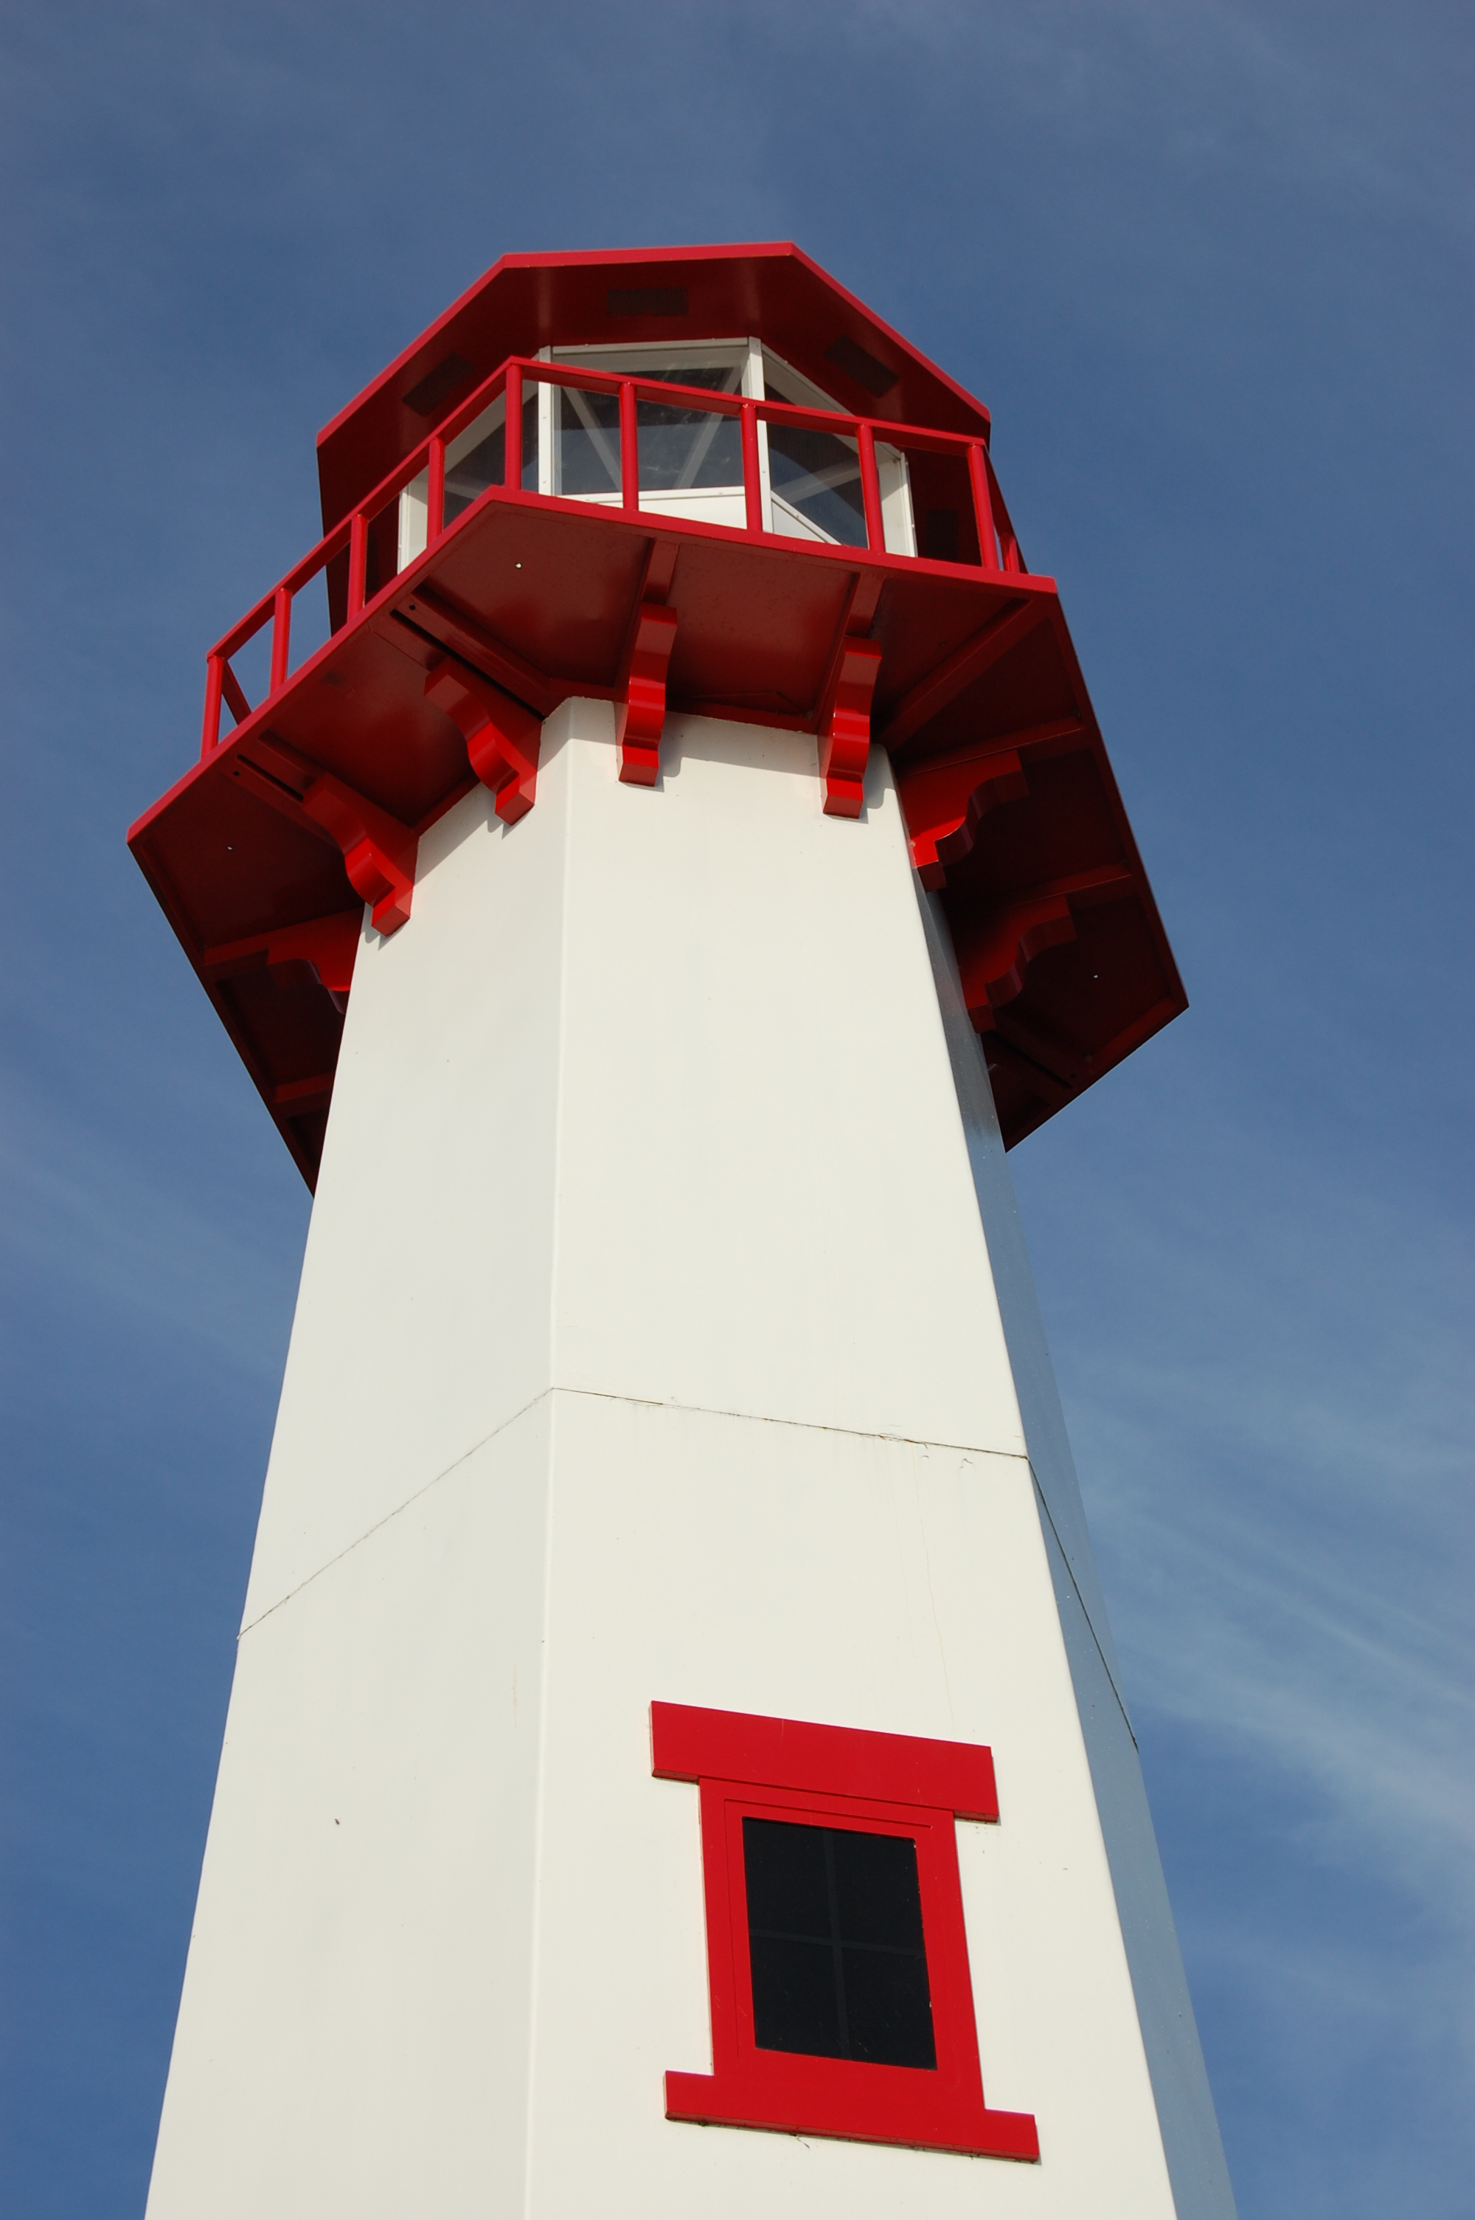
THE LIGHTHOUSE

Newsletter for October 2016

Light is shed upon the righteous and joy on the upright in heart.
Psalm 97:11

Message from Our Pastor

Dear Sisters and Brothers in Christ,

Many years ago, I remember talking to a dear friend about a situation that was troubling me. I remember telling him “it feels like all I can do is pray about it”. His response was something that touched me deeply. “David, praying is the most you can do, put it in God’s hands and trust the Holy Spirit will guide you on what needs to be done”. I have tried to live that way since then, and to be honest trusting that God will see me through it, hasn’t let me down yet. Yes, there have been times when I’ve had to wait for an answer. And there were times when the outcome was totally different than what I had been expecting. But God, through the Holy Spirit, saw me through it, and for that I give thanks.

The Church is in difficult and challenging times. Finances and declining attendance, over the years, are two of the biggest issues. We’re not alone in this situation. Many churches are experiencing these challenging times across the nation. I wish I had an answer for how we can fix this problem, but I don’t. But I do know where to begin, and that’s with prayer.

With October, church activities are beginning to pick up. As we try new and different things, along with the things we have been doing, I invite you to join me in prayer. Asking daily for the Holy Spirit to guide us down new paths and trusting God’s plan for us in the future. In my office in the parsonage, I have a verse printed on a piece of paper hanging on the wall and its 1 Chronicles 28:20 and I think it’s fitting for the times we are in,

‘Be strong and of good courage, and act. Do not be afraid or dismayed; for the Lord God, my God, is with you. God will not fail you or forsake you, until all the work for the service of the house of the Lord is finished’.

May October be filled with the blessings of a beautiful fall season.

Yours in Christ,
Pastor David

Newsletter

The Newsletter was adopted by the family of
Reuben & Mildred Gustafson



Reuben
4/7/1900 – 9/30/1977

Mildred
8/5/1914 – 9/19/2006

Noisy Offering

The noisy offering for October 2nd will go to Lutheran World Relief.

Ladies Luncheon

On October 2nd after church the Ladies of Zion are having a luncheon for all the ladies of church, please feel free to join us for some fun and good food. See you there,
Karen Schlehuber

Conference Meeting

Our yearly Conference Meeting is 4 pm at Zion in St. Ignace on October 2nd. It is a pot-luck and all are welcome. We will be updating our plans for the Conference/Synod.

Conference meetings are meant to be a time to consider how congregations can partner together in ministry, a time to share ideas, and to elect new leadership. Your attendance is encouraged!

Adult Bible Study

Adult Bible Study will begin October 5th at 7 pm. Please join us in the Zion Family Center!
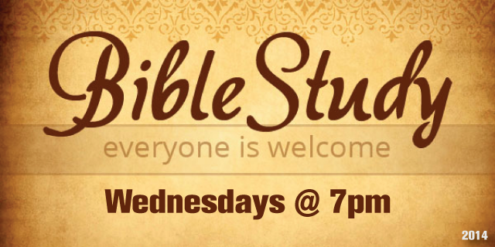

Confirmation Meeting

Confirmation will be on the 2nd Sunday of each month from 5 – 7 pm. The first meeting will be October 9th.

Pasty Sale

On October 22nd and 23rd we will be making pasties for the Pasty Sale in November. Please come and help. There will be jobs for all (taking orders, making them, delivering them on the Friday before hunting season) A sign up-sheet will be will be in church on the 9th and 16th of October for workers and for donations of rutabagas, potatoes, chicken, roast beef, onions, carrots, flour or Crisco shortening. We also would like for some people to make soup to sell during the weekend sale in McDonald’s parking lot

Thank you very much,
Karen Schlehuber & Lana Lennington

NOIZ

The NOIZ Youth Group will have a Fall Kick Off on Sunday October 16th at 6 pm.

This event is for 12 - 18 year-olds. Please join us for a bonfire with s’mores, hotdogs and fun outdoor games. Bring a friend or 2 or 3. The more the better!
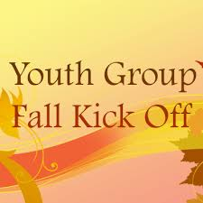

Thank you!

I want to thank everyone for their generosity in donations for funerals and the Lion’s dinners. It is appreciated!
Linda Wilkins

Family Fun Night

October 30th from 4 - 6 pm is Zion Family Fun Night. Join us for food, fun, games, and fellowship. Wear your costumes and be prepared to use your imagination!!!
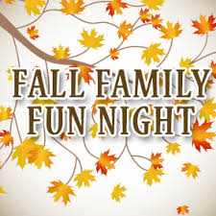

Acolyte Robes?

We are looking for the Acolyte Robes. They are missing from behind the altar. Anyone who might’ve taken them for whatever reason, please return them to the church!

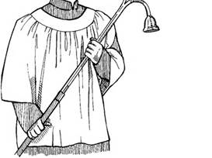

????

HOPE Chest

The new winter HOPE Chest hours are:

Fri - Mon: Closed
Tues: 10am - 4pm *donation drop-offs 10-4
Wed: Noon - 6pm *donation drop-offs Noon-5
Thurs: 10am - 4pm *donation drop-offs 10-4
Volunteers are needed! Please consider giving of your time and talent to our mission. Our volunteers are vital to the success of the HOPE Chest. There is a wide range of volunteer positions available, during open hours and on Wednesday evenings from 6 - 8 pm to stock shelves. Please stop in to see how you can help or call Cathie Tielbar at 643-7360.

Baptismal Anniversaries

October 5 Sara Sorenson
5 Anthony Lester

7 Sarah Doran
11 Nicole Garen
17 Michael Lennington
17 Jim Ryerse
17 Gavin St. Onge
20 Les Therrian
23 Gary Sorenson
24 Gunnar Olsen
25 Jon Olsen
25 Sally Idalski
25 Haley Dodds
27 Andrew Sjogren
27 Jacob Sjogren
28 Denise Maxson
Birthdays in October

October 1 Dylan Shepard
6 Kristen Olsen
6 Saylor Sorenson
8 Teagan Ferguson
9 Jeff Gamble
19 Ray Baron
20 Madison Olsen
22 Katti Gamble
23 Ivan Schlehuber
25 Logan DeKeyser
25 Ken Smith
25 Michael Gustafson (and Lara)
26 Judy Massey
27 Steven Campbell
27 Kristi Gustafson
27 Mike Wilkins
27 Jeanne Rose

Anniversaries in October

October 11 Ray & Shari Baron
15 Mike & Barb Lehto
27 Dave & Rita LaVake

Zion Funeral Committee Aug - Nov

Team Leader: Linda Wilkins (430-1465)
Co-leader: Rita LaVake (906) 298-0005

Servants for Zion

Ushers & Greeters
Oct 2 NOIZ
Oct 9 Alan & Betsy Turf
Oct 16 Confirmation Youth
Oct 23 Hilda Ryerse & Lynn Evans
Oct 30 Nicole Garen Family
Lectors
Oct 2 Lynn Evans
Oct 9 Loni LaJoice
Oct 16 Sandy Feleppa
Oct 23 Cathie Tielbar
Oct 30 Fred Feleppa
Acolytes
Oct 2 Josh Feleppa
Oct 9 Brendan Insley
Oct 16 Ellie Tielbar
Oct 23 Bailey Ryerse
Oct 30 Matthew Valletta
Communion Assistants
Oct 2 Steve Christiansen
Oct 9 Jerry Fenlon
Oct 16 Mary Christiansen
Oct 23 Paul Shepard

Altar: Susan Fenlon
Money Counters: Lana Lennington and Donna Harju

The Usher duties are:
- Arrive 30 minutes before church
- Pass out bulletins and welcome guests
- Help with the offering and communion
- Record attendance

We will be providing the Long Term Care Service on Oct 2nd. Please help out if you can.
Trinity Worship Families

Oct 2 Movalson Family
Oct 9 Baron Family
Oct 16 Chalmers Family
Oct 23 Rose Family
Oct 30 Kennedy Family

Council Meetings

Trinity Council – 6 pm, September 20th
Zion Council – 6:30 pm, September 21st

Zion’s Council Members
President: Lana Lennington 643-6576
Vice-President Paul Shepard 984-2069
Co-Treasurers: Dawn Akers 643-7552
Co-Treasurers: Lana Lennington 643-6576
Secretary: Steve Christiansen 298-1051
Mary Christiansen 235-6123
Jerry Fenlon 643-8730
Tim Idalski 643-6574
Karen Schlehuber 643-0311

Trinity’s Council Members
President: Jerri Rose 292-5570
Vice-President Tracy Movalson 292-5581
Secretary: Sharon Chalmers 292-5440
Treasurer: Pega Kennedy 292-5633
Co-Treasurer: Jim Rose 292-5570
Financial Secretary: Tom Gustafson 292-5460
WELCA: Pega Kennedy 292-5633
John Kennedy 292-5633
Lois Movalson 292-5581
Treasurer's Report for Zion
January 1, 2016 through September 24, 2016
Income:
 | Amazon Smile Foundation | 15.45
 | Building | $ 160.00
 | Church Use Income | $ 391.00
 | General | $ 50,029.65
 | Memorial Fund | $ 25.00
 | Thrivent Financial Income | $ 44.00
 | Trinity Share | $ 11,116.22
 | TOTAL |  | $ 61,781.32
Expenses:
 | Administration | $ 4,171.13
 | Benevolence | $ 383.97
 | Church Maintenance | $ 8,540.49
 | Education | $ 290.78
 | Parsonage Maintenance | $ 2,278.71
 | Pastoral | $ 43,653.67
 | Worship | $ 3,591.53
 | --To Building Fund | $ 100.00
 |  |  | $ 63,010.28
 |  |  | -1,228.96
***********************************************************
Thrivent Financial Investment Fund |  |  | $ 273.11
General fund balance: |  |  | $ (1,817.13)
Kitchen/Building Fund balance |  |  | $ 2,049.33
General fund owes building fund: |  |  | $ 60.00
General fund owes Mission Endowment fund: |  |  | $ 7,995.00
Zion Lutheran Council Meeting
September 7, 2016

Council Members Present: Jerry, Pastor Dave, Dawn, Lana, Tim, Mary, and Steve.

Lana called the meeting to order at 6:38 pm.

Pastor Dave opened with devotions.

1. Pastor's Report:

A. Pastor will be gone in the end of October and will arrange for pulpit supply.

B. Pastor has been in communication with synod about the renewal process and our church's financial situation. Bishop has reassured us that we are heading in the right direction and that we are not alone. Council and congregation will begin a study of a book entitled Unbinding the Gospel to better understand alternatives for increased congregational stewardship. Pastor would also like Council to complete a congregational checkup sheet before our next meeting and he distributed the forms.

2. Secretary's Report:
Secretary's Report was discussed and approved.

3. Treasurer's Report:
Treasurer's report was discussed and approved.

4. Old Business:

A. Elevator repair: Another potential repair company is Kone Inc. out of Wyoming MI who services other elevators in the UP.

B. Fund Raisers:
1) Soup luncheons will resume in January.
2) Pasty sales will start and orders can be placed starting in October. Pasty preparation days will be identified soon, with a target of 300-500 pasties. Pasties and possibly soup will be advertised and sold along US Highway 2 corridor during firearm deer season. (more on this to come).

New Business:

A. Church Budget: Council discussed the financial situation of Zion and there was agreement some action has to be taken in order for us to meet church expenses. In addition to the stewardship study and fundraisers mentioned earlier, Council looked at using some money from the endowment fund to meet expenses. We reviewed our Church Constitution and determined that use of the endowment funds to meet expenses is allowed after presenting it to the congregation through a special congregational meeting and receiving a majority vote of approval. Council discussed and unanimously approved a proposal to use $10,000 of the endowment fund to meet current and upcoming expenses. This proposal will be presented for discussion and congregational decision at the September 11, 2016 service.

B. Thanks to Mike Wilkins for washing the back of the church!

Meeting was adjourned with the Lord’s Prayer at 7:45 PM.

Respectfully Submitted,
Steve Christiansen

Zion Lutheran Congregational Meeting
September 11, 2016

An Emergency congregational meeting was held following worship on Sunday, September 11th.
A letter had been mailed to all members advising of the reason for the meeting.

We opened with a prayer.

Council President Lana Lennington advised the congregation that we were unable to pay the pastor’s salary the prior week and we have not had enough income to pay our monthly expenses.

After considerable discussion, Sandy Feleppa made a motion that we withdraw $10,000 from the Endowment Fund no later than October 3rd. Seconded by Lynn Evans. Passed.
It is hoped this will be sufficient to keep our doors open through the end of the year. It is critical that member give regularly even if not attending. If giving does not increase, it is highly likely that we will be unable to keep the church open more than a couple of years. We will also be doing fund-raising projects and encourage participation by all able members.

The meeting closed with a prayer.

Notes respectfully submitted by Judy Ryerse

Contact Information

Pastor David Tielbar may be reached at 906-984-2051 or at david.tielbar6@gmail.com. In an emergency, you can reach the Pastor’s cell phone at (563) 880-4512

Church telephone: 906-643-7870 - Answering machine
The secretary will usually be in the office on Tuesday and Thursday mornings from 9 – 12

To email the church is: ziontrinity950@yahoo.com
The website is at http://zionstignace.com/home.html
- Find us on facebook at www.facebook.com/zionstignace

Zion Evangelical Lutheran Church and Trinity Lutheran Church are congregations of the Northern Great Lakes Synod and the Evangelical Lutheran Church in America.

Trinity’s Sunday Service is at 9 a.m.
Zion’s Sunday Service is at 11 a.m.

Prayer List

(If you would like someone added to the prayer list, please call or email the church)

Mary Belonga, Dave & Lois Movalson, LaTaunya Paquin, Barb Lehto, Charlie Lamoreaux, Ed Idalski, Luanne Keinonen, Joel Morabito, Judy Schlehuber Bridges, Jackie Rippit, David & Connie Ogg, Tom & Taffy Coffey, Ed Heenan, Eric Rose, Charles Beeck, Phillip Brooks, Joe & Sharon Chalmers, Joanne Tamlyn, Bethany Wiese, Nadine Dandona, Patty Thibault, Dan Levay, Bruce McVannell, Jim Rose, Gayle Kaminsky Pande, Christine Jamieson, Alfie Dyer, Christine Scott, Charlie Dowd, Virginia Gustafson, Rick, Kirk and the families & friends of Eleanor Hastie and Carl Belonga


ZION
Youth and Family Ministry

Join Us
We invite you to join us as we gather in the name of Jesus to learn, grow and have fun!

Where
Zion Family Center
999 State Street
St. Ignace, MI

Something for Everyone!
For Information or to help call
Pastor Dave @ 563-880-4512

Confirmation
2nd Sunday of each month from 5 to 7 pm

Family Night
Last Sunday of each month from 4 to 6 pm. Fun food and fellowship

Sunday School
Preschool – 5th grade during 11 am service

Adult Bible Study
Wednesdays from 7 to 8 pm

NOIZ Youth Group
Meets monthly

